Indiana Student Standards for Guidance Addressed
Standard(s) addressed: |  | Indicator(s)  addressed:
Instructional Development
Grade Level(s): | 9-12
Title: | Yorktown High School
Summary: | What You See Is What You Get shows kids how to dig below the surface of popular media images of relationships between friends and boyfriends or girlfriends. Kids analyze trend-setting music, magazines, videos, and other media to figure out what they are seeing and why advertisers use these images. Kids come out of What You See Is What You Get with the understanding that they can choose respect in their own lives. Kids are surrounded by media—ads, movies, music, video games, and the Internet and they love it! They also like to talk about it. The media show the good, the bad, and the ugly of relationships, and it’s important for kids to understand how the media influences their behavior.
Time Frame: | 83-85 minutes
Procedure: | - Introduce yourself.  - Introduce the activity.  - Ask: How many of you have looked at magazines, have watched TV, or have a Facebook account? (All students will likely raise their hands or indicate that they have.)  - Ask: How many of you have noticed advertisements on TV, on the internet (e.g., Facebook even has ads now) or in magazines?  - State: Today we are going to look at some ads from magazines to see what kinds of messages are in advertising. We are going to work in groups to find messages that are disrespectful and respectful in magazine ads.  - Get students in groups of 3-5.  - Give each group a stack of advertisements.  - Ask students to work together for about 10-12 minutes to find messages of respect or disrespect in the ads.  - Allow representatives from each group, or multiple members from each group to share what they have found in the advertisements.  - Allow for discussion of the messages either after students are done reporting their findings or throughout their reporting.  - Ask:  - Who is the target audience of the magazine you selected and also the ad?  - What strategies are used to sell the item?  - Is beauty being used to sell the item? If not, explain. If so, explain how beauty is being used.  - How are colors used?  - What is the point of the ad?  - What assumptions does your ad make about people or our society?  - If there are figures in the ad, what are they like? What does the ad say about age, sex, ethnicity, education, gender, etc.?  - Do they think ads should be different? Why or why not?  5 minute break then regroup!  - Say:  - Now that you’ve gotten a general idea about the messages that are being sent in magazine ads, let’s take a look at a music video.  - Ask: “By show of hands, how many of you have seen Eminem’s Love the way you lie.”  - Most of them and maybe all of them will have seen it. However, Prior to discussing the video, discuss the cycle of violence. Draw the diagram below and discuss each stage.  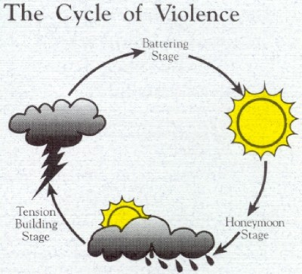  Honeymoon stage (making-up)  - Abuser may apologize for the abuse  - Abuser may promise it will never happen again  - Abuser blame the victim for causing the abuse  - Abuser may deny abuse took place or say it was not as bad as the victim claims  Tension Building Stage  - Abuser starts to get angry  - Abuse may begin  - There is a breakdown of communication  - Victim feels the need to keep the abuse calm  - Tension becomes too much  - Victim feels like they are “waling on egg shells”  Battering Stage  - Any type of abuse occurs (physical/sexual/emotional)  Remind that not all abusive relationships fit the cycle exactly. After explaining the cycle, ask them if they have any questions.  Prior to screening the video, tell the students to look for signs, lyrics, and scenes in the cycle of abuse in the video. Be specific.  Clean Version: http://www.youtube.com/watch?v=Po9hcTf1eZQ  Version w/ profanity (mute): http://www.youtube.com/watch?v=uelHwf8o7_U  *  Debrief the questions.
Evaluation
How will mastery of the guidance indicator(s) be evaluated? | - Students will recognize the role of media in influencing ideas about what dating should be like.  - Students will report that media portrays unrealistic ideas of what a dating partner should look like.  - Students will be able to identify the cycle of violence in relationships
Learning Resources
Resources needed:  e.g., technology resources, media resources, books, web sites | - Magazine ads to analyze  - Internet access to screen YouTube video
Citation(s):  You may include copyrighted materials in “resources needed,” but do not reproduce copyrighted materials in your lesson plan. Non-copyrighted materials need to be reproduced and included with your lesson plan. Cite sources here. | http://chooserespect.org/scripts/materials/materials.asp

